Analysis of the Impact of COVID 19 on the bank’s borrowing portfolio

# Task:

I was tasked with looking into a Bank’s data and analyze the impacts of the Coronavirus pandemic on banks overdraft portfolio. Look into how the portfolio has changed as the UK was put into lockdown in March 2020 and what actions I think the business should take. The database contained two tables:1. **accounts_sample** - A list of customers who have an overdraft enabled along with some key characteristics of them.

**2. monthly_performance** - One row per customer per month with performance data on how they are using their overdraft between January 2020 and July 2020

# Method:

I used Bigquery to run key queries on the data using sql joins, view, stored procedures to gain deeper insight. I started by asking myself a series of questions needed to analyze the data. I wanted to know based on the credit band who had the ‘remaining overdraft’, the left over overdraft, changed over time, why they had changed, how did they coincide with the UK Lockdown news cycles.

What do these tables look like individually?

SELECT *

FROM analytics-take-home-test.monzo_borrowing.accounts_sample;

SELECT *

FROM analytics-take-home-test.monzo_borrowing.monthly_performance;

--- What do these tables look like together?

CREATE VIEW combined_bank AS

SELECT m.account_id,

s.credit_score_band_at_origination,

s.annual_interest_rate,

m.DATE,

m.account_status,

m.overdraft_balance,

m.overdraft_limit,

m.in_financial_difficulties_flag,

m.total_value_transactions_made

FROM monthly_performance m

INNER JOIN accounts_sample s

ON s.account_id = m.account_id;

-- Look at view --

SELECT * FROM combined_bank;

-- Create a function that determines if the account is overdrawn beyond the limit

DELIMITER $$

CREATE FUNCTION is_overlimit(balance FLOAT, limit FLOAT)

RETURNS VARCHAR(20)

DETERMINISTIC

BEGIN

DECLARE customer_status VARCHAR(20);

IF limit > balance THEN

SET customer_status = 'YES';

ELSEIF (limit = balance)THEN

SET customer_status = 'MAYBE';

ELSEIF limit < balance THEN

SET customer_status = 'NO';

END IF;

RETURN (customer_status);

END $$

DELIMITER;

SELECT *, is_overlimit(overdraft_balance,overdraft_limit) AS customer_status

FROM combined_bank

WHERE customer_status = 'N0';

-- Given the credit band, how more likely are they going to be in their overdraft over time.

SELECT m.DATE,

s.credit_score_band_at_origination,

Sum( m.overdraft_limit - m.overdraft_balance )

FROM monthly_performance m

INNER JOIN accounts_sample s

ON s.account_id = m.account_id

GROUP BY s.credit_score_band_at_origination,

m.DATE

ORDER BY s.credit_score_band_at_origination,

m.DATE;

-- Count the proportion of different bands in the portfolio. Has that proportion changed

-- With the proportion

SELECT m.DATE,

s.credit_score_band_at_origination,

m.in_financial_difficulties_flag,

Sum( m.overdraft_limit - m.overdraft_balance ) AS difference

FROM monthly_performance m

INNER JOIN accounts_sample s

ON s.account_id = m.account_id

GROUP BY s.credit_score_band_at_origination,

m.DATE,

m.in_financial_difficulties_flag

ORDER BY s.credit_score_band_at_origination,

m.DATE;

-- How many people are close or over their overdraft limit? How has this changed#

SELECT s.credit_score_band_at_origination,

Avg(m.overdraft_balance),

Avg(m.overdraft_limit),

AVG(m.overdraft_limit - m.overdraft_balance),

Avg(m.total_value_transactions_made)

FROM monthly_performance m

INNER JOIN accounts_sample s

ON s.account_id = m.account_id

GROUP BY s.credit_score_band_at_origination

ORDER BY s.credit_score_band_at_origination;

-- What factors would be necessary in understanding the health of a borrowing portfolio?

SELECT s.credit_score_band_at_origination, s.annual_interest_rate

FROM monthly_performance m

INNER JOIN accounts_sample s

ON s.account_id = m.account_id

GROUP BY s.credit_score_band_at_origination, s.annual_interest_rate

ORDER BY s.credit_score_band_at_origination, s.annual_interest_rate;

# Key Findings:

From my analysis, I found that when the UK went into lockdown the most affected credit band was C, then D and E. People with higher credit score utilities their overdraft more reflecting possible financial hardship and reliance on their overdraft to foot the bill. This quickly recovered. Whereas people with lower credit scores did not experience significant changes to their overdraft utilization most likely due to the fact that they were already utilizing their credit significantly.

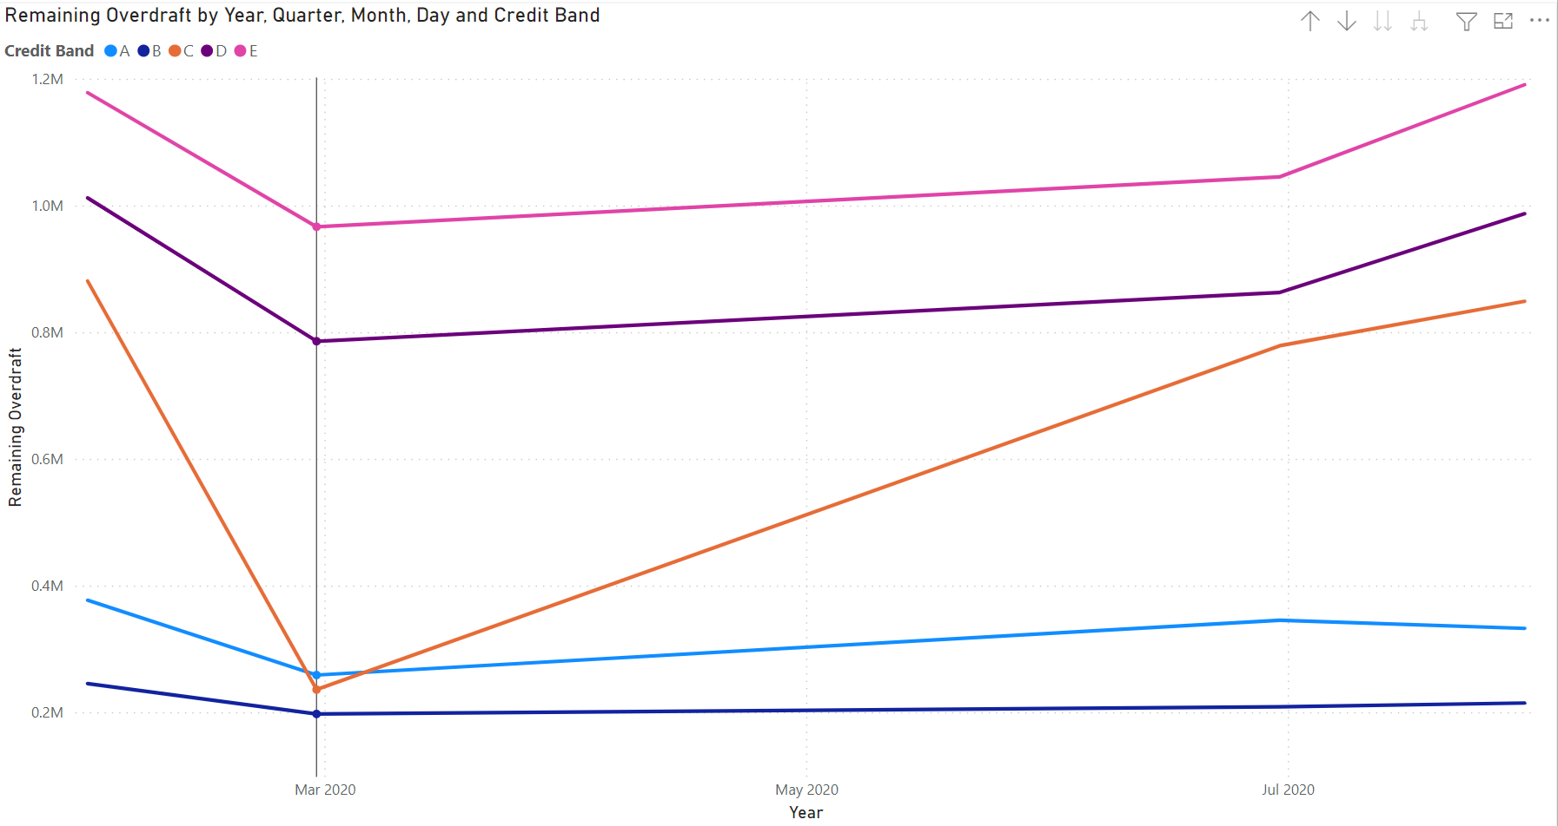

# Conclusion and Recommendations:

I would recommend that as a business opportunity to increase the interest rates for band C, D and E to increase profits, but focus on C. Band C interest rates are split into 19% and 29% annual interest rates. Shifting the whole band to 29% would increase profits as lockdown increases usage of overdrafts. I would also suggest more financial safety protection and care for this group C. They seem to be financially resilient to bounce back from Lockdowns as well.